

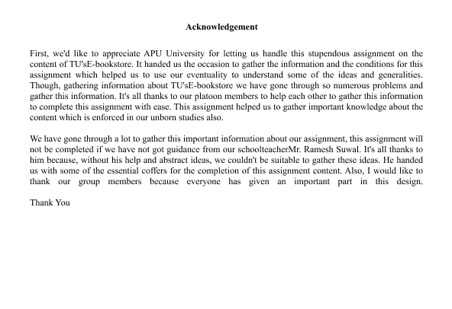

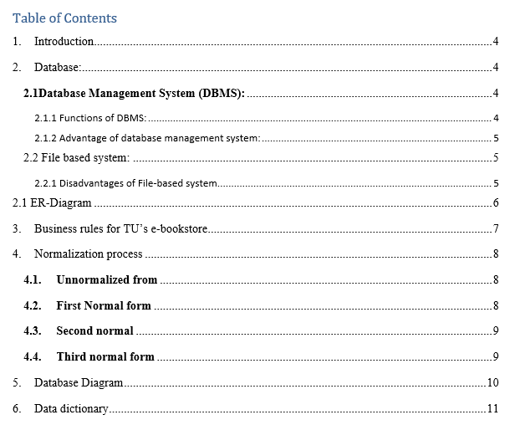

# Introduction

The Tribhuvan University (TU) E-Bookstore Systems developed an online platform to combat unlawful access to books within TU. The project aims to create a complete database system capable of managing feedback, client registration, inventory control, and book orders. In addition to monitoring book availability and optimizing purchasing procedures, the system accommodates TU's growing student base, resulting in a productive online buying experience and a dynamic learning environment.

# Database:

A database is an orderly collection of structured data. Data is a digital picture saved on a personal computer. It refers to both the technology used to store and retrieve such data and the people who utilize it, which includes database hardware and software.

A database system, commonly abbreviated as a database, includes the data, DBMS, and associated applicationsInvalid source specified..

## **2.1Database Management System (DBMS):**

A database management system may be required to run the database. A database management system connects a database to its end users or applications, allowing them to access, update, and manage information organization and optimization. A database management system (DBMS) enables database supervision and administration, such as performance monitoring, tweaking, backup, and recoveryInvalid source specified.

### 2.1.1 Functions of DBMS:

* The database metadata repository in which DBMS stores data information.
* Databases support the query-based data retrieval and analysis.
* DBMS implements preset constraints and rules to guarantee data integrity.
* Proper coordination and transaction execution assure by DBMS.
* Data access is controlled by DBMS that allowed viewing and updating.
* Multiple users' concurrent access to databases is maintained by DBMS.
* For execution plans, DBMS evaluates and improves query performance.

### Advantage of database management system:

* DBMS allows for quick changes in database structure independence.
* DBMS removes unnecessary information within the system.
* DBMSs use integrity requirements to ensure correctness and consistency.
* DBMS improves data security by allowing only allowed access.
* Recovery processes monitor and correct data during malfunctions.
* Reduced total effort due to modifications without affecting applications.
* Centralized databases facilitate data exchange for projects.
* DBMS allows for efficient management of large volumes of data.

## **2.2 File based system:**

A file-based system DBMS is a type of software that enables users to enter and calculate small amounts of data. Typically, they come with a computer's operating system. They save and retrieve data from storage devices such as hard disks and flash drives (webopedia.com, n.d.).

### 2.2.1 Disadvantages of File-based system

Data in a file-based system is relatively dangerous since it might be associated with a variety of files and locations, and it can be lost. The data may be found in several locations.  
  
Copying data led to redundancy and increased storage demands.  
  
· Difficulty transferring data across departments.  
  
· Using file-based solutions may make it difficult for applications to trade data.  
  
· As the number of users increases, the likelihood of data deletion or errors increases.  
  
· System modifications demand significant development and maintenance costs.

# 2.1 ER-Diagram

Entity Relationship Diagram can be referred as the Er-Diagram. A fault diagram is a visual representation of a database which assists with comprehending the database's logical architecture. An Er-diagram can be summarized up in three basic concepts. (Peterson, 2021):

–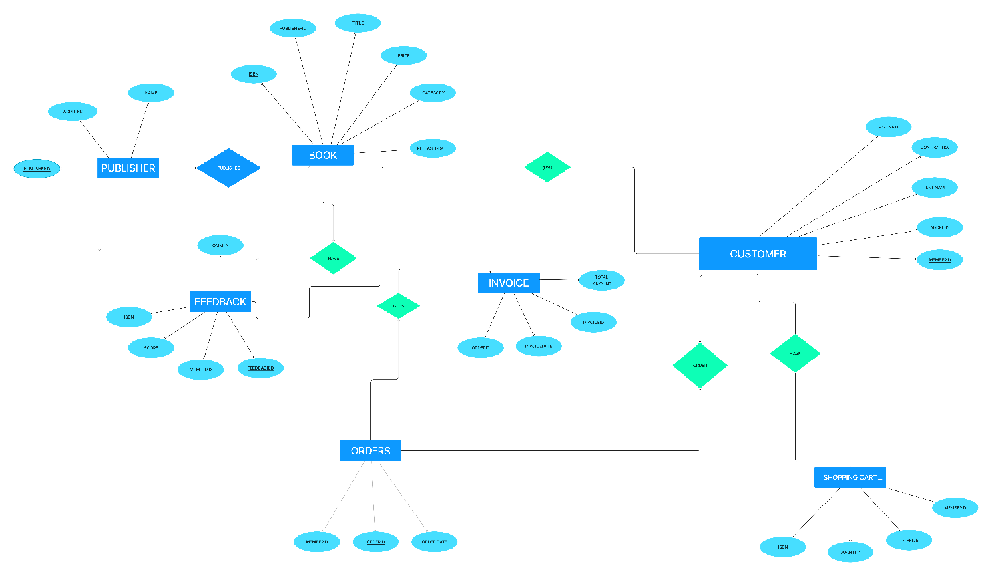

# Business rules for TU’s e-bookstore

Following are the business rules for TU’s E-Bookstore that can fulfill the requirement.

* Registering as a library member requires acceptable identification and contact information.
* Members receive a unique library card number upon registration.
* Members must provide a valid library card to borrow books.   
  Members can borrow up to five books at a time.
* The borrowing duration is two weeks, with the opportunity to renew for another two weeks if no holds are found on the book.
* To avoid late fines, return books by the due date.
* Members with overdue books cannot borrow new goods until they are returned.   
  Members can reserve books that are already checked out by other members.
* Reserved books must be picked up within 3 days after notification.
* Each book is assigned a unique ISBN number.
* The catalog provides information about title, author, genre, and availability status.
* Late fees apply to each overdue day at a predetermined rate.   
  Members are responsible for safely returning borrowed books.
* Members will be charged for missing or damaged books based on the current replacement cost.
* The library system may host activities including book readings, workshops, and lectures.
* Members receive information about forthcoming events and can register to attend.   
  Access to the library database is limited to authorized staff.
* Regular backups of the database avoid data loss.
* Members can request books from other libraries via interlibrary loan services.   
  Interlibrary lending requests require permission.
* Member information, including borrowing history, is confidential and should not be released unless the member expressly consents.

# Normalization process

The procedure of normalizing the database serves minimize irregularities in updates and data dependence. It evaluates the data set applying the candidate key or primary key and other functional relationships that are present in the data structure (geeksforgeeks, 2022).

## **Unnormalized from**

In the design of databases, normalization is a method of organizing data to get remove unwanted linkages and repetitions. It seems to indicate that there are a few book names in one cell of the "book name" column in your case, which might end up in mutual & partial dependencies that are functional. This could give rise to redundant records and hinder handling of data.

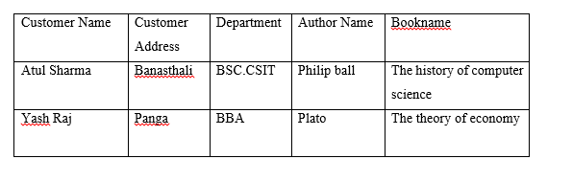

## **First Normal form**

A unique value key, occasionally referred to as an index key, is needed to recognize tables in relational databases with the goal to address the complicated problem of duplicates that occurs while trying to find data. The value of this key is then employed to identify information to perform query or other change (techopedia, 2011).

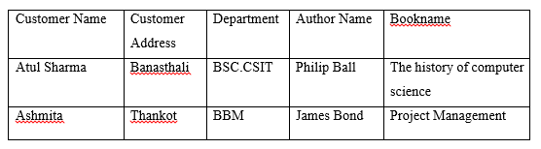

## **Second normal**

Only once a 1NF relation is needed is a 2NF table constructed. Each non-key property in this normalization is entirely dependent on its primary key that acts like a unique defining key. Another usual version gets away with depend on the primary key. (Diwan, 2020).

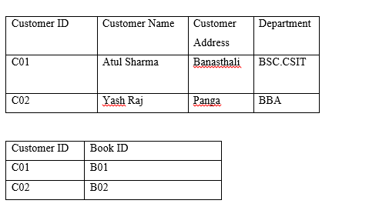

## **4.4Third normal form**

3NF refers to the third normalization step. Only after a table is in 2NF and without a recursive functional connection is it regarded as being in 3NF. (Diwan, 2020).

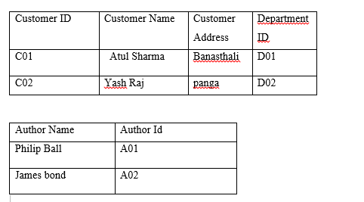

# Database Diagram

The data contained in a database is expressed visually in database layouts. The link between a foreign key and primary key is depicted in a database diagram. Using a database feature in the database we've created, we can create a database diagram (jetbrains, 2020).

**Finalized Database Diagram**

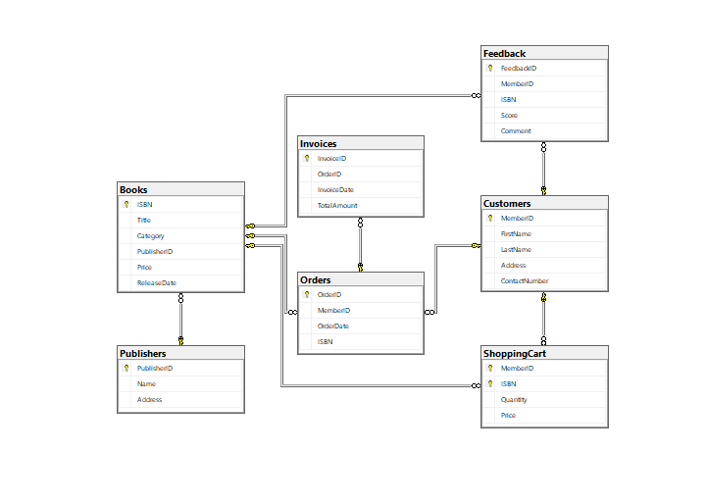

# Data dictionary

There are several locations in a file-oriented system that implement data security to varied degrees, which occasionally results in loss. The dataset is stored in many locations (tutorialspoint, 2020).  
  
A data dictionary in a database management system is a collection of metadata about data objects. It contains descriptions, definitions, and names for many of these items. This information, which is used by database administrators and programmers, needs to be handled in order to maintain data clean and correct (scaler).

**Publisher Table:**

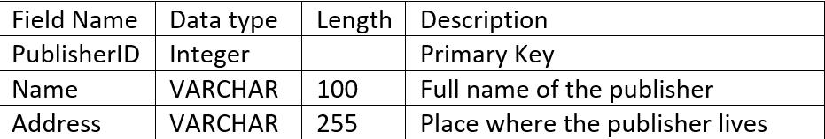

**Book Table:**

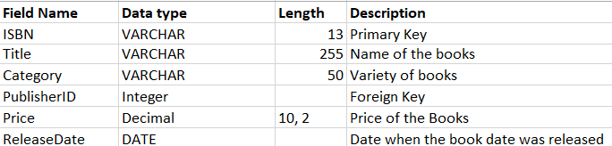

**Customer Table:**

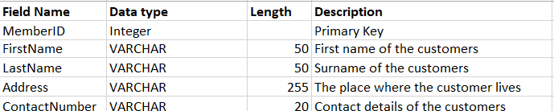

**Order Table**

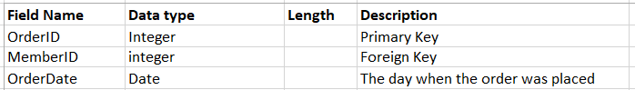

**Invoice Table:**

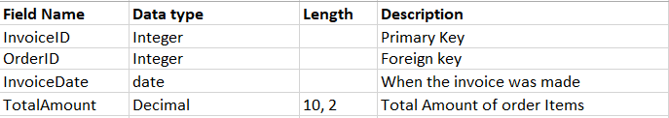

**Feedback Table:**

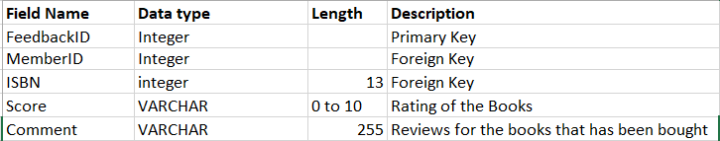

**Shopping Table:**

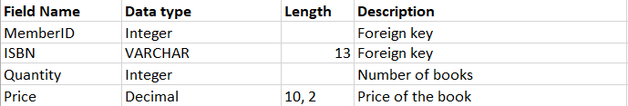

**References**

(2020, June 20). Retrieved from tutorialspoint: https://www.tutorialspoint.com/What-is-Data-Dictionary

coursehero. (2023, 02 27). *Unanticipated queries in a file based system handling*. Retrieved from coursehero: https://www.coursehero.com/file/p7t8d8g/Unanticipated-Queries-In-a-file-based-system-handling-suddenad-hoc-queries-can/

*Database Business Rules Importance*. (2023, 02 27). Retrieved from relationaldbdesign: https://www.relationaldbdesign.com/database-design/module4/business-rules-importance.php

Diwan, A. (2020, June 15). *Second Normal Form (2NF)*. Retrieved from tutorialspoint: https://www.tutorialspoint.com/Second-Normal-Form-2NF

geeksforgeeks. (2022, 09 13). *Normalization Process in DBMS*. Retrieved from geeksforgeeks: https://www.geeksforgeeks.org/normalization-process-in-dbms/

jetbrains. (2020, December 20). *Database diagrams*. Retrieved from jetbrains: https://www.jetbrains.com/help/phpstorm/creating-diagrams.html#:~:text=Database%20diagrams%20graphically%20show%20the,using%20primary%20and%20foreign%20keys.

myreadingroom. (2023, 2 20). *What is DBMS? Advantages and Disadvantages of Database Management System(DBMS)*. Retrieved from myreadingroom: http://www.myreadingroom.co.in/notes-and-studymaterial/65-dbms/462-advantages-and-disadvantages-of-dbms.html

Peterson, R. (2021). *guru99*. Retrieved from https://www.guru99.com/er-diagram-tutorial-dbms.html#:~:text=ER%20Diagram%20is%20a%20visual,Ellipses%20%3A%20Symbol%20represent%20attributes

scaler. (n.d.). Data Dictionary In DBMS. pp. https://www.scaler.com/topics/data-dictionary-in-dbms/.

skfdjskdfjs. (n.d.). *sdfsdf*. Retrieved 2014

techopedia. (2011, 12 08). *What Does First Normal Form (1NF) Mean?* Retrieved from techopedia: https://www.techopedia.com/definition/25955/first-normal-form-1nf

webopedia.com. (n.d.). *What Is a File-Based Data Management System? | Webopedia*. Retrieved from webopedia: https://www.webopedia.com/definitions/file-management-system/#:~:text=A%20file-based%20data%20management%20system%20(also%20called%20a%20file,hard%20disk%20or%20flash%20drive.

xgxdfd. (n.d.). *xxfdxd*. Retrieved 2010